**UWP’s Bid for Nationals 2019**

Hello everyone, my name is Erik Zander, a content writer and current player on the Platteville Dodgeball club. The Platteville Dodgeball Club is placing a bid for nationals to be held at the University of Wisconsin Platteville. It would be a great honor to hold the national tournament and to try to make it one of the best nationals to date. I would be the person in charge of running this event along with my Dodgeball UWP board who are all eager for this opportunity. I’m currently in my last year and I want to use nationals as my capstone course for my education. If given the opportunity to host the league would receive regular updates on the status of nationals and what can be expected for that weekend. I’m currently talking to the Platteville Chamber of Commerce and they can help me get access to sponsors to help with the costs and provide teams with great deals on lodging and food. I’m also talking to the National Guard in being a sponsor as a few of the courts that will be used for nationals are ran by them. I’m also going to be in contact with our organization on campus soon that provides funds to events such as this to help reduce the costs for the national tournament making it easier on all teams in attendance. This organization is always looking for events like nationals to provide funding for so there is a good chance we will receive funding for this.

**Facilities-**

We currently have 8 to 9 courts available for use and I’m working on obtaining a few more. This would allow the games to get done early which would allow for teams to have more free time afterwards to hangout and relax before Sunday’s play. The four main courts will be on our campus which all have dividers on them and no walls so there is no bounce back that can occur. There is great viewing from above so that one can watch multiple games at once. The gyms at the high school are new and have bleachers on the sides so that it provides for great viewing of the matches. The armory in Platteville also has courts run by the national guard (a potential sponsor of the event) that the NCDA will have access to.

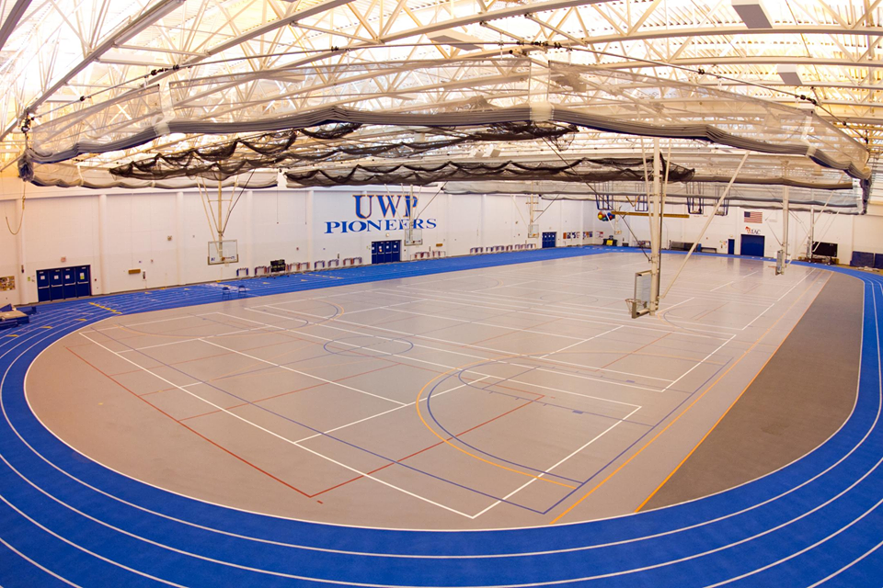

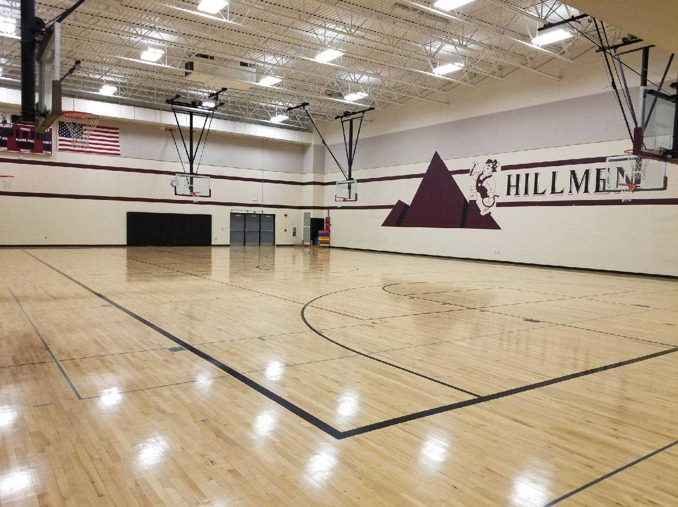

**Officiating-**  If nationals is held at UWP the NCDA will have access to multiple referees since several of the alumni of UWP and DePaul that actively follow the teams would love to have the opportunity to help with such an event. They are close enough that getting them to travel and help would not be an issue. This would allow for fewer games needing to be refereed by current players and allowing them to enjoy the matches. Also, these individuals will have a good understanding of how the current rules work because the Platteville Dodgeball Club hosts two summer events that these individuals partake in and UWP also holds two tournaments throughout the year that the alumni also participate in too, so they will have a good understanding of how the game is played and how the rules should be enforced. I will also provide these individuals extra training on how they should referee and make sure they understand the rules clearly.

**Balls-** I know at previous nationals, the quality of the balls and them being broken in has been an issue which can affect a team’s ability to play. At Platteville, we do a really good job at breaking them in, just ask Grand Valley as they really liked using our dodgeballs at their tournament. With the balls purchased, the Platteville Dodgeball club would rotate the balls throughout the year to get them ready for nationals.

**Captain’s meetings-** At our fieldhouse, we have a room that is used by the sports teams to have team meetings and this room is set up like a lecture hall, so it can easily fit the captain’s meeting with everyone able to have a seat and be comfortable.

**Lodging-** We have several hotel options in town for use such as: The Holiday Inn, Country Inn, Mound View Inn, and a Super 8. The surrounding area also has several hotel options that are right there making the distance to travel to the facilities short and quick to get to. With several options for hotels, I will be able to obtain deals for the teams to reduce costs further. I know that the hotels in the area always look for events like this, so they should be able to provide excellent offers to help everyone out.

**Food-**  Platteville offers several options for food and the best part is that they are all along Main Street or on our business Hwy 151. If you are in the mood for fast food restaurants there are several that are available to teams. We have McDonald’s, Culvers, Milo’s, Jimmy John’s, Subway, Dairy Queen, A&W, Taco Bell, Taco John’s, Domino’s, Pizza Hut, and KFC. Now, if you are looking for more sit-down type restaurants to socialize those options are available too. Some of these options include: County Kitchen, Los Amigos, Fiesta Cancun, China Buffet, Parkway Grill, The Ticket Bar and Grill, Spirits Bar and Grill, Steve’s Pizza Palace, Pizzeria Uno’s, and Owl Café. We also have a few coffee shop options too, in Badger Brother Coffee, and 2nd & Main Coffeehouse and Pub. Also, we have our student center right across from the fieldhouse, so you can order food from there and if you are 21 you can enjoy the local brewery that is on tab. Pioneer lanes also offers excellent food and a banquet area for your team to hang out and bowl if you so desire. As you can see, there are several options that you can chose from and they are in a short distance of each other making it easy to get to.

**Parking-** On the weekends, parking is free on campus and most of the parking lots are empty so finding parking should not be a problem. The high school also offers plenty of parking.

**T-shirts-** The Platteville Dodgeball Club has been getting its shirts and apparel from a local company for several years (RBS Activewear) and they are easy to work with and provide quality products. I have never have had any problems working with them and are always good at communicating. I have been talking to them and they are looking forward to such an opportunity to work with the league and provide a design for the national shirt that everyone will enjoy as well as for the all-star match.

**Additional information-** Besides the topics mentioned above, there are other things that might interest you. At Platteville, we also have other activities that can be taken advantage of. For example, all of you disc golf lovers out there (SVSU-Kenny Mize) UWP offers an 18-disc golf course on campus as well a 9- hole course off campus. Platteville is a small area, so traffic is never an issue and there is no city noise. It is safe to walk around and explore, and as I stated everything is on one drag, so you cannot get lost. We also have the World’s Largest M that you can climb that provides a great scenic view of the country side. I’m also in talks with the Bus Transportation System in Platteville to provide teams with free service of taking individuals to and from places without charge. These are just some of the things that Platteville has to offer and there are many more things and deals to come if able to host the national tournament. Platteville is a small area and locals are willing to offer more because holding an event such as this would be beneficial to our community.

<http://ncdadodgeball.com/blog/nationals-2017-hosting-bids/6956>

<http://ncdadodgeball.com/blog/my-recommendation-for-nationals-2018-host/10112#more-10112>