**Penn State University: NCDA Nationals 2019 Proposal**

After hosting two successful tournaments during the 2017-2018 dodgeball season, Penn State would like to officially place a bid to host the NCDA Nationals 2019 at our university in University Park, PA.

**Facilities**

We would utilize our Intramural Building for the weekend. This is our largest multipurpose facility with all of the required amenities and more. We have ten (10) playable total courts in the IM building. Three (3) have curtains all in one room that are suitable to host three games at once. Three more courts do not have separators, but we would definitely be able to hold two games on the far courts and use the middle court as a general area for check in and other purposes. This room also contains an upper level for viewing. There are also three (3) additional courts with dividers towards the back of IM Building that includes an upstairs indoor track that spectators can use to view games from above (as well as get a better angle for filming). In the middle of IM, there are also two multipurpose courts as well. That would bring the total to 10 courts. Additionally, we have 10 racquetball courts for warming up, the fastest arm contest, storage, etc. There is also a large conference room downstairs which may be used for the captains meeting, so we wouldn’t have to walk several blocks like we did at VCU in 2018.

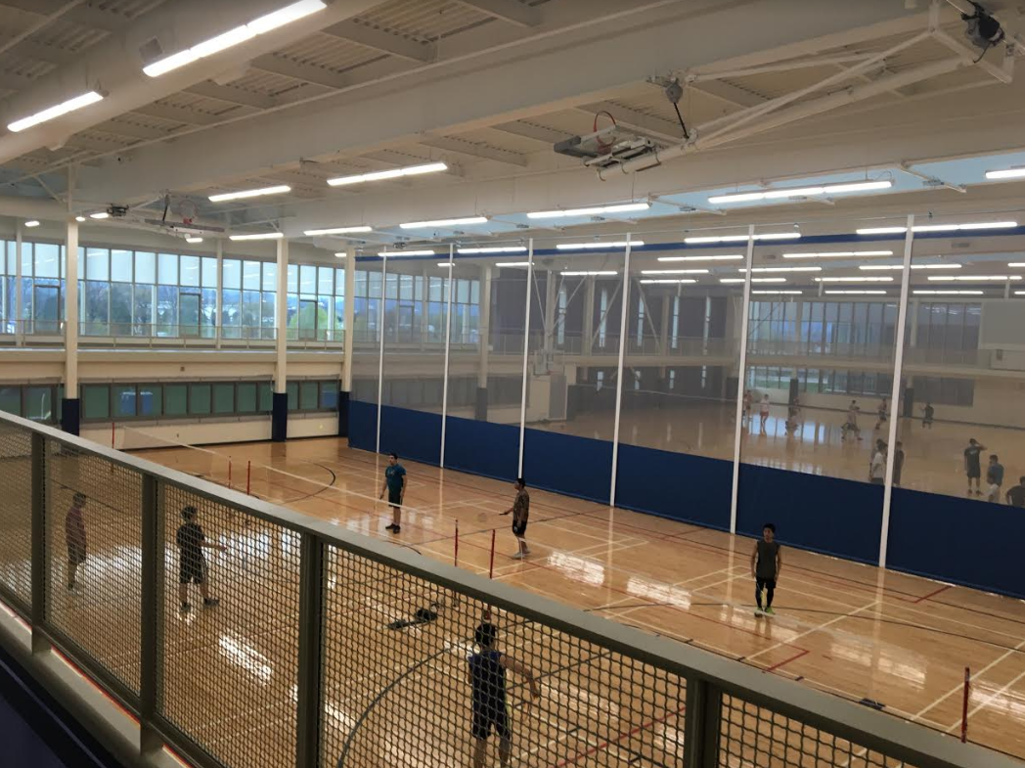

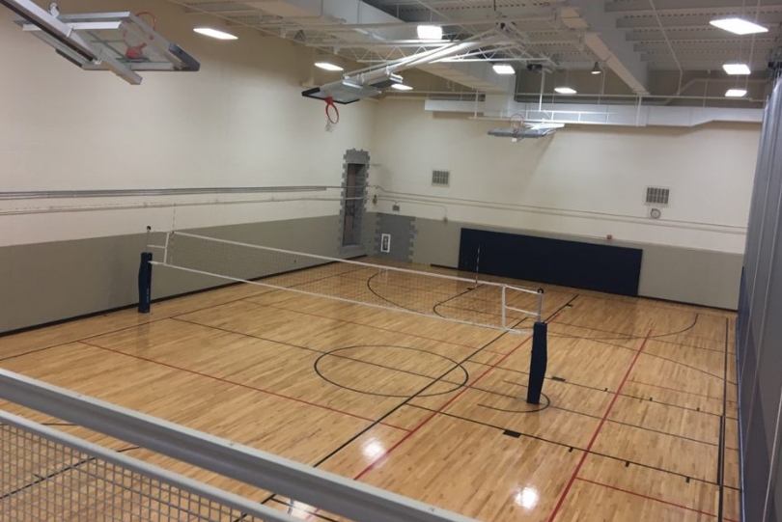

**Parking**

East Parking Deck is approximately a block away from IM building. We can also work on gaining access to the commuter parking lots across the street from the IM building next to Beaver Stadium. These lots are mainly used for parking during Penn State football weekends. The lots will be more than enough to accommodate all of the dodgeball teams that attend Nationals, and all are within a 5 minute walk from the facility.

**Friday Night Option**

We are able to rent out IM Building for Friday evening if there are additional games required to be played on Friday night.

**Officiating**

As with Nationals 2018, each team would be responsible for officiating designated games along with the help of NCDA staff and alumni. We will also have 10-20 club sports staff members on hand helping things run smoothly throughout the day for any injured players or off-court issues.

**Wi-Fi**

Penn State Club Sports can work with Penn State Wireless to accommodate each team with free Wi-Fi for live streaming, internet, and communications at no cost.

**Lodging**

There are many hotels in the area that are cheap and about 5-10 minutes away from campus. We will be working to see if there is a way to receive any deals from any hotels in the area. Our university hosts more than 100,000 visitors on football weekends; there will be ample availability for NCDA teams to find close lodging for the weekend.

**Food**

State College has a wide variety of food and dining options. A few of these include Chick-fil-A, Chipotle, Primantis Brothers, Waffle Shop, Taco Bell, $1 slices at Canyon, McDonalds, and numerous other options in order to quench your hunger.

**Bars**

There are plenty of bars to host all the 21 year olds coming to Nationals. All are downtown and within walking distance of each other. Ubers are relatively cheap, ranging from $6-$10 to get downtown. You got the iconic Phyrst, Champs with 8 pool tables and lots of arcade games, a night club at Indigo, Cafe 210, which has some outdoor space, and Pickles, the best of them all. Whatever scene you’re into, you’ll find it somewhere downtown.

**Questions**

We’d be happy to answer any questions or address any comments! Thanks, and have a great summer!

Best wishes,

Jake Nasiadka #2