James Madison University
Facilities
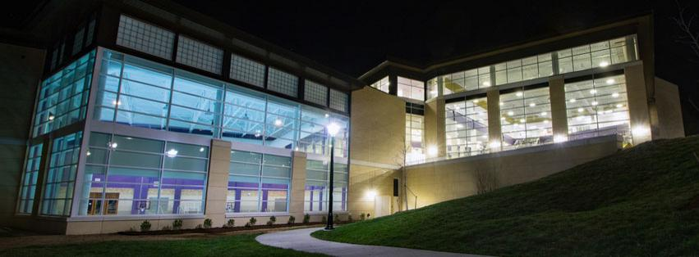
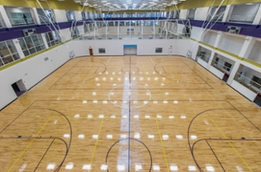
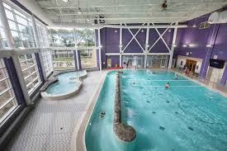
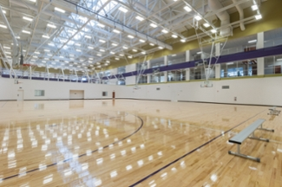
JMU’s University Recreation Center (UREC) is a new, state-of-the-art, $137 million-dollar complex spanning a total of 280,000 square feet. We would have access to 5-7 courts (all with functioning and usable scoreboards as well as dividers) over the course of the weekend, with the potential of even hosting some Friday night games. This gym has it all, from tons of viewing areas surrounding every court, to a huge pool, hot tub, and sauna area perfect for relaxing after a long day of dodgeball. The gym has the capacity to EASILY accommodate upwards of 800 people coming to nationals if we are looking at an ambitious figure. There are viewing areas above the courts, perfect for recording or livestreaming games, as well as glass penalty box type areas on the courts perfect for seating more spectators. We would also have racquetball courts reserved for teams to warm up in and/or keep their stuff, as well as a meeting room that can accommodate up to 200 people, perfect for the captains’ meeting as well as hanging out between games. Moreover, there is a dining facility in the main lobby that specializes in rice bowls comparable to Chipotle’s, and at a very reasonable price. When OSU and MSU made the trip for BEAST this past year, both teams were blown away with how amazing our facility was (see photos below). The building has full Wi-Fi capability, great cell service, and outlets all over every wall. As far as facilities around the league go, JMU’s is the nicest, and most fit to host a national tournament for the growing NCDA
Hotels and Lodging
After doing a quick Google search, I found that there are 25+ hotels within 5 miles of JMU’s campus, starting around as little as $50. We are extremely confident in our ability to get group rates at some of these hotels, as it has been done before by other JMU sports clubs. In addition, there is an abundance of large cabins within a 15-minute drive, in places like Massanutten, a local ski resort, that rent for the weekend at great rates.
Surrounding Area
Harrisonburg is a safe and secure area that has a lot to offer for visitors for the weekend. If you’re into the outdoors and “neature” is your thing, the Shenandoah Valley is perfect for hikes, long or short, as well as some breathtaking views. For those of you who are looking for a social experience, JMU never comes up short in that category, as many of you know. Friday and Saturday night could be accommodated to get large groups of people together for good times at very reasonable costs.
Food
Of the NCDA schools, JMU’s will take anyone to town in the food category. On campus food is ranked in the top 10 nationally every year by Princeton Review, and for good reasons. Not only would the dining facility INSIDE the gym be open, but there would be others open within a 5-minute walk. On top of that, there are over 75 restaurants within 2 miles of campus, ranging from B-Dubs to tons of local favorites with low priced food and beer (for 21-year old’s of course). Harrisonburg’s cost of living is ridiculously low, resulting in high quality restaurants at insanely good prices. With JMU club sports’ involvement in the community, a catered lunch on Saturday could have a high probability, or, from experience, a great pizza deal could be guaranteed. We all obviously like to eat, and everyone would leave Harrisonburg after a JMU Nationals more than satisfied with their dining experiences throughout the weekend.
Additional Perks
These are all wildcards, but are things that we believe should be taken into consideration along with all the previously mentioned great things.
- An East Coast Nationals could do wonders for the exposure of the league. With JMU’s centrality on the coast, it would be perfect for getting the word out about the NCDA to the immense number of schools within a few hour radius. It is also a reasonable location for a lot of the newer programs to get to for nationals, which could help retention numbers a lot. JMU’s popularity has been growing rapidly over the past few years with our new gym, the expansion projects of programs like our College of Business, and hosting College Gameday and winning an FCS National Championship. With all the buzz surrounding the school, us hosting NCDA Nationals could bring more attention to the sport.
- As Mike Hinely previously stated, an East Coast Nationals would free up a lot of money in the budgets of the teams in the area to travel around the country throughout the year, which would be a positive for everyone in the league. Seeing as the number of teams in Michigan and Ohio is high, the drive to JMU is a bit closer than the drive to VCU, and thus would be a little more “central” in regards to the league as a whole, if we are looking solely at the East Coast.
- This is not a knock on any other captains or presidents around the league, nor is it me neglecting anyone’s efforts, but I am extremely confident in the abilities of myself and my executive board to put on a spectacular national tournament. We are all really excited with the thought of hosting nationals, and have already been brainstorming tons of ideas on how to make it the best nationals yet. After seeing the past two nationals run extremely well, I’d like to be the next in line to continue making NCDA Nationals awesome. With my involvement at JMU and community ties, I know we would be fully prepared to put on Nationals for hopefully upwards of 30 teams.
- I can personally guarantee that you will NEVER have to read a horrendously written post from Mike Hinely ever again.

Thank you for your consideration, and if you have any further questions, don’t hesitate to reach out and message me!
- Doug Schilling

